The Netherlands

Best practices and development

Sustainable urban planning
- Alphen aan de Rijn; Ecolonia
- City of Apeldoorn; fully integrated planning process involving all disciplines.
- Investment Budget for Urban Regeneration (ISV); a subsidy measure in the field of accommodation, space, environment and the physical conditions. ISV is a powerful instrument for applying Sustainable Building to existing towns (extra attention on urban development and existing stock).

works, process

policy
- The Ministry of Housing, Spatial planning and the Environment (VROM) has set up, within the framework of the National Environmental Policyplan, the Policy Programme on Sustainable Building 2000-2004. Main goal is to bring Sustainable Building (SB) to a higher level:
- wide application: SB will be widely applied in the building sector by the public sector, developers, designers and consultants and builders.
- suitable conditions: SB is involved in policies, agreements, legislation, provision of know how development and dissemination.
- Sustainable Building is one of the instruments with which the government together with the building sector are giving form and concern to the Sustainable Development of Dutch society. It is about the sustainable development, renovation and maintenance of buildings or works and their environment as a whole, including the demolition and removal.
- National packages on Sustainable Building. National Packages for the different building sectors: housing sector, Utility building, the Civil Engineering Sector and Urban Development.

agreements
- SB-agreements public sector and building sector

harmonisation, normalisation and certification
- EcoQuantum: assessment method (design tool) for calculating the environmental load for dwellings based on both material based environment figures and environmental loads caused by living. LCA-based technical specifications
- Programme on building construction and demolition waste management
- Environmental declarations building product (MRPI)
- Dutch NEN-standard Material-based Environmental Profile for Buildings (MEPB)

works, projects

housing sector and non-residential sector
Demonstration projects for sustainable and low-energy building. The demonstration projects, in addition tot serving as examples, were also to contribute to the ‘upwards leap in scale’. 47 projects (31 housing construction an 16 non-residental construction) are carefully monitored, generally from drawing tot completion.

roads and earth embankment structures
- National Package on Sustainable Building in the Civil Engineering Sector (: Sustainable Building measures);
- Implementing measures in the Standard Conditions of Contracts for Works of Civil Engineering Constructions;
- Energy saving programme for the Civil Engineering Sector.
- SB-demonstration project Motorway A12 (Utrecht-Veenendaal)

Sustainable building policy

Recent history
In the nineties, the Dutch government decided upon a stimulus for sustainable building. In 1995 the first Action Plan with fourteen actions and projects was presented. This marked the beginning of the Dutch government’s programmed approach to sustainable building. It was aimed to give sustainability a stronger place in the decision-making process on the layout and use of buildings and their environment. In 1997, the second Action Plan followed with 28 actions and projects. Both plans were developed in consultation and close co-operation with the representative organs of all parties involved in the building process. Both plans have had much effect. By the end of 1999, sustainable building has become an important theme in the building process.

Policy Programme 2000-2004
However, in 1999, government and market parties concluded that is was still too early to drop the programmed approach of sustainable building. More time is needed for wide application of sustainable building and embedding it in the daily practice of construction.
Therefore the Policy Programme Sustainable Building 2000-2004, titled "Firmly Embedding", has been presented at the end of 1999. Aim of this programme is that, at the end of this period, sustainable building will be completely embedded in thought and deed of government and construction organizations and that the stimulus of the programmed approach will no longer be needed.
The Policy Programme contains extra policy stimuli in three areas. Energy is one of them. The international agreements on reduction of emission of greenhouse gases require additional effort also from the building sector. Especially existing buildings offer opportunities for this. Therefore the instrument of the energy performance advice is being developed, based on voluntariness.
A further impulse is also needed for sustainable urban development. Recent developments in the field of urban regeneration offer opportunities for sustainable building to make leaps forward.
Third and last extra policy stimulus regards the approach of consumers in their role of demanders and users of buildings. There is still a great potential hidden in the consumer’s increasing demand for quality. Promising is the possibility of linking sustainable building to other quality aspects such as comfort, availibility of green space and water nearby, quality of life and public health.

Implementation Programme 2000-2002
The Policy Programme contains an Implementation Programme for 2000 and 2001, with over thirty projects, to be carried out in close co-operation with the market parties. By the end of 2001, the Policy Programme will be updated on the basis of the experiences. The Policy Programme will be evaluated at the end of 2003 in order to draw well-founded conclusions for the future of sustainable building policy.

Sustainable building regulation

Towards environmental performance standards for buildings - a description
Sustainable building in the Netherlands has become firmly embedded in governmental policy since 1995. Policy has been elaborated in successive action plans. The core of the action plans are actions grouped along four policy lines, namely: "harmonisation", "realisation", "consolidation" and "preparation". The policy line "harmonisation" is of crucial importance for the building sector. To achieve this, the building sector itself took the initiative to develop a series of so-called "national packages for sustainable building".
So far, functionally formulated measures and solutions were used. However, the building sector prefers formulations in terms of performance requirements which allow designers and builders to choose freely from the solutions they want themselves. This approach is in compliance with Dutch building regulation.
Just as is the case with determining the energy performance of a building, it should be possible to also ascertain its environmental performance. Research into devising a determination method is presently going on and has meanwhile resulted in a prototype method for drawing up a building's material-based environmental profile, derived from the existing, performance-based LCA (life cycle assessment) method. With the help of such a method, socially desirable minimum standards for sustainable use of materials can in due course be incorporated into the building regulations. The use of performance standards leaves room for innovation and creative solutions.
This leaflet presents the method and provides background data and information on future developments in the Netherlands.

Unambiguous environmental information
Sustainable development means minimising environmental pollution so that our children and grandchildren can continue to live in healthy surroundings. Sustainable building contributes to this by ensuring more economical use of finite raw materials and by reducing and above all preventing the accumulation of pollutants and waste. The incorporation of sustainable building standards into the building regulations was mentioned as a goal in the "Sustainable Building Action Plan: investing in the future", published in 1995.
Practically all the players in the building sector need clear environmental information to support their decisions. At the moment they can obtain such information by making use - on a voluntary basis - of instruments such as Eco-Quantum and GreenCalc. If there is a standardised method of assessment, however, all the players in the sector will be required to use the same method and to base their agreements on it. Everyone's decisions will then be based on the same environmental information. If the standardised method is incorporated into the building regulations, this will ensure that it is used by the "stragglers" as well as the "front runners".

A single yardstick for environmental performance of materials, the Material-based Environmental Profile for Buildings (MEPB)
Future building regulations could include a new performance standard known as the Material-based Environmental Profile for Buildings, or MEPB. "Material-based" means that the profile solely concerns the materials used in the building. The MEPB reveals the environmental impact of the use of materials throughout their life cycle.
The MEPB is a yardstick for the environmental performance of all the materials used in a building. It can be used to draw up environmental profiles for both licensable and non-licensable structural components, installation of materials, and structural and other fixtures. Just as in the case of the energy performance coefficient, the building regulations can lay down limit values, starting with the housing construction sector. As elsewhere in the building regulations, the MEPB can be drawn up with reference to standards published by the Dutch Institute for Standardisation (NEN).
In 2000 the Netherlands Minister of Housing, Spatial Planning and the Environment will decide whether to adopt new regulations on the subject. If adopted, such regulations could take effect from 1 January 2002.
Environmental performance standards in 6 steps
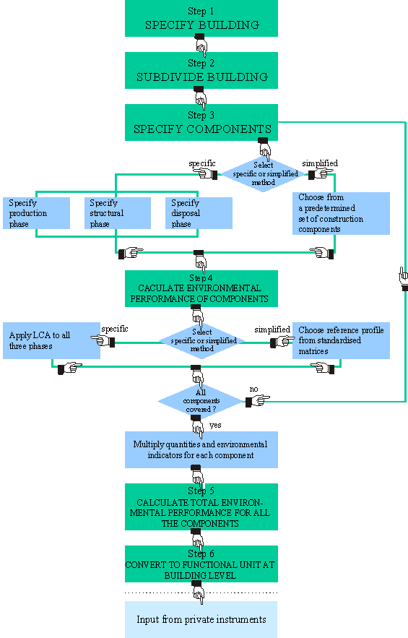
The steps in detail
The method for drawing up the MEPB consists of six steps:
step 1: Specify the building
The user specifies whether the building is (a) a dwelling which is not located in a residential structure or (b) a residential structure. He determines the usable surface area (in accordance with Dutch standard NEN 2580) and the working life of the building.
step 2: Subdivide the building
The building is subdivided into:
(a) licensable structural components (structural component: a component which is used in the construction of a building and which is subject to building regulations under the terms of the Building Decree);
(b) non-licensable structural components;
(c) other fixtures.
step 3: Specify the components
The user chooses which specification method he wants to use for each structural component. He can choose either
(a) the specific method,
(b) the simplified method, or
(c) a combination of the two.
For the production phase, the structural phase and the disposal phase of each component, the user indicates:
- what products the component consists of, and in what quantities;
- what activities are carried out;
- what kinds of waste are generated, and in what quantities;
Specific method
The user draws up his own list of components.
Simplified method
From a predetermined set of components, the user chooses the ones that are applicable to the building.
Combined method
The user chooses components from a predetermined set of components and adds some of his own.
step 4: Calculate the environmental performance (the environmental profile) of the components
The environmental profile is calculated using the method selected in Step 3: specific, simplified or combined.
Specific method
The user determines the environmental burden generated during the production phase, the structural phase and the disposal phase of each component. The environmental burdens for all the various products, activities and types of waste are then added up. The result is an environmental profile for each component. Information supplied by manufacturers can also be used for this purpose.
Simplified method
The user starts by drawing up the required environmental budget per unit of the component (e.g. per m² expressed in an environmental profile). For this purpose he can make use of predetermined "reference profiles" drawn up on the basis of profiles for large numbers of components, or he can use "ready-made" producer-specific environmental profiles for components. A compilation of environmental product information sheets can also be used if available.
The environmental profile per unit is then multiplied by the quantity of the component (e.g. 100 m² of interior wall). The result is the environmental profile for the component concerned.
An environmental profile is expressed in terms of environmental impact categories, in other words the thirteen types of environmental impact or the five environmental value standards (see below information on environmental impact categories).
step 5: Calculate total environmental performance (add up the environmental profiles) of all the components
The environmental profiles for the various components are added up.
step 6: Convert the environmental profiles to a reference unit
On the basis of the data recorded in Step 1 (including surface area and working life), the results from Step 5 are converted to a unit which enables them to be compared with the standard. This eliminates differences in environmental impact due to the type of building (mid-terrace dwellings, end-of-terrace dwellings, bungalows, etc.) and so allows proper comparisons to be made. The specific details of this step are still being studied.
Example of how the steps are applied
step 1: Specify the building
Our example is the "Novem" sun lounge reference dwelling. The usable surface area of the dwelling is 111 m². The estimated working life of the dwelling is 75 years. It is a mid-terrace dwelling in a row of eight.
step 2: Subdivide the building
The building is subdivided into its component parts. The user then takes one of the structural components - the window frames, which are licensable - and proceeds through Steps 3 and 4, using the simplified method.
step 3: Specify the components
According to the specification, there are 18 m² of window frame in the reference dwelling.
step 4: Draw up the environmental profile of the components
Using the simplified method, the user proceeds as follows:
The type of window frame to be used in the dwelling is known. The user takes the types of environmental profile from the corresponding environmental profile and subsequently calculates the environmental performance of the dwelling, using the appropriate calculation units. Alternatively, the type of product used for the window frames may not yet be known. In that case the user selects indicators/environmental budgets within which the environmental profile of the window frames to be used must fall.
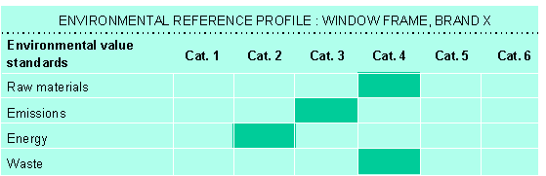
Key: Step 4, using the simplified method. The type of window frame and the corresponding environmental profile are known.
step 5: Add up the environmental profiles of the components
The user adds the environmental profile for the window frames to the profiles for other components used in the dwelling. The total is the environmental profile for all the materials used in the dwelling.
step 6: Convert the environmental profiles to a reference unit
The user converts the environmental performance of the dwelling to the functional unit (e.g. square metres of usable surface area).

Background

Integrated environmental assessment
The various players in the building sector want to see integrated environmental assessment of buildings. The energy performance coefficient has been an integral part of the regulations since 1995. Radiation and water performance standards are currently being developed. Noise abatement and other health aspects are covered by the building regulations. These are all components of integrated environmental assessment of buildings. This leaflet focuses on the development of another component, the material-based environmental profile for buildings (MEPB) - one more step on the way towards integrated environmental assessment of buildings.

Total life cycle
The assessment method is based on life cycle assessment (LCA), which covers the entire life cycle of a building. The life cycle of the building consists of three phases:
- Production phase: the production of building products, from extraction of raw materials, transportation to the factory and production of semi-finished products, to the finished product at the factory gate.
- Structural phase: all the activities involved, starting with transportation of products to the building site, construction, maintenance and replacement, and ending with demolition. Each activity involves products (such as façade components), subsidiary activities (such as hoisting), accessories (such as props), equipment (such as hoists), and waste that requires disposal.
- Disposal phase: from transportation of demolition material to final disposal (dumping, incineration, recycling or reuse).
The environmental performance of each component and activity, as well as any waste generated, is determined for each phase. The sum total represents the environmental performance of the building.
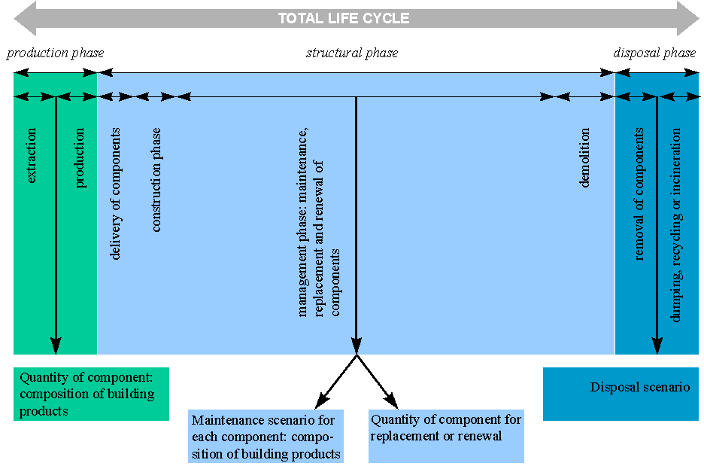

Life cycle assessment (LCA)
LCA examines the entire potential environmental impact of a product "from the cradle to the grave". It provides a picture of the entire life cycle of a product (from extraction of raw materials to demolition and recycling), of the processes that take place during that life cycle, and of their environmental interactions and impact. Environmental interactions are raw materials and energy. Environmental impact means depletion of raw materials and fossil fuels, release of emissions, and generation of waste. After an inventory of the environmental impact has been drawn up - using various calculations which are subsequently standardised as part of the assessment method - the various performances are put together to create an environmental profile. The environmental profile reveals the environmental impact of the product in question.

Environmental profile
An environmental profile is made up of environmental characteristics. These may be the thirteen types of environmental impact or the draft five Dutch environmental value standards, namely raw materials, emissions, energy, waste and nuisance (the nuisance value standard is not yet operational). The thirteen types of environmental impact are depletion of raw materials, depletion of fuel resources, the greenhouse effect, damage to the ozone layer, summer smog, human toxicity, ecotoxicity in water, acidification, eutrophication, use of non-renewable energy resources, waste, hazardous waste, and radioactive waste. The draft five Dutch environmental value standards are determined after weighing the thirteen types of environmental impact.

What will this mean in practice?

Changing responsibilities
When the new procedure is introduced, all applications for building permits will also be assessed for compliance with the new environmental performance standards. This will affect the responsibilities of many of the players in the building sector:
- Those commissioning new structures will be responsible for deciding what measures must be taken to comply with the limit values and for providing an environmental profile of the structure.
- Designers will be responsible for making calculations and producing designs which meet the standards for the MEPB.
- Local authority housing inspectors will be responsible for assessing applications for building permits and ensuring compliance with the terms of the permit.
- Contractors will be responsible for carrying out the work in accordance with their instructions, i.e. in accordance with terms of the building permit.
- Suppliers will be responsible for supplying products which will enable applicants for building permits to comply fully with the MEPB for the structure concerned.

Application procedure
The MEPB must be submitted to the local authority together with the application. The procedure is the same as for the strength of a structure. In practice, it is expected that building permits will include a clause stating that the calculations demonstrating compliance with the MEPB will be submitted at a later stage. The calculations must be submitted before the structural components are used. Calculations submitted in connection with building permit applications will often be based on knowledge of families of building products and the corresponding indicators. Detailed choices of products and producers will be made later. Products and producers must be chosen in such a way as to comply with the MEPB. In the event of failure to comply with the MEPB, an application must be made to have the building permit amended. By choosing different components and corresponding environmental profiles, evidence can then be provided that the limit values have been complied with after all.

Consultation platform
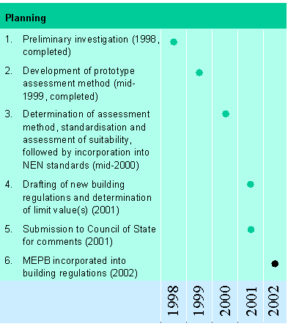
The Building Regulations Consultation Platform (OPB) has set up a Steering Group on Sustainable Building Standards in the Building Regulations to supervise the incorporation of MEPBs into the building regulations. The OPB is a forum for consultation on building regulations between market players in the building sector and the Directorate-General for Housing of the Ministry of Housing, Spatial Planning and the Environment.
The current prototype has been submitted to the OPB and will be discussed there before proceeding to the next stage.
The assessment method was designed by a consortium consisting of TNO-Bouw and TNO/MEP (the building and environmental sections of the Netherlands Organisation for Applied Scientific Research), IVAM Environmental Research, W/E sustainable building consultants, Intron, and CML.

Further information
For further information on the incorporation of sustainable building standards into the building regulations, please contact P. J. van Luijk, e-mail: piet.vanluijk@bd.dgvh.minvrom.nl, or H.W. Verkès, e-mail: henk.verkes@bd.dgvh.minvrom.nl, at the Netherlands Ministry of Housing, Spatial Planning and the Environment.

